LCLS LLRF Reference
R.Akre
September 2, 2008
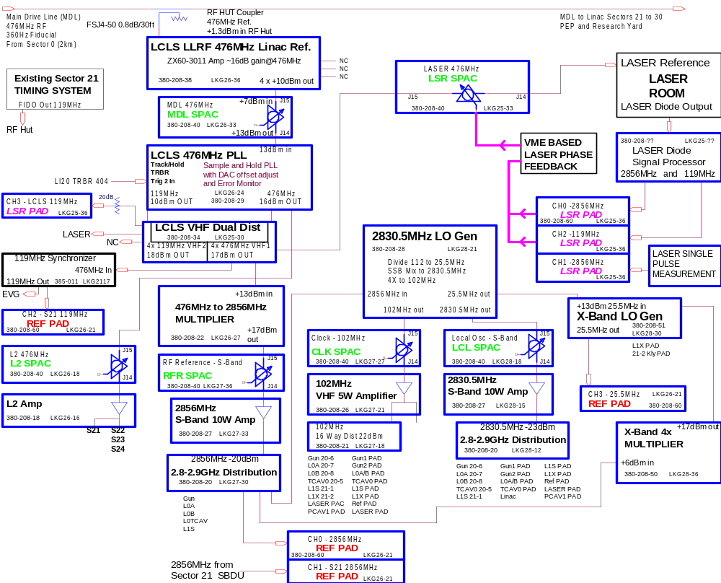

Figure 1. LCLS Sector 20 LLRF distribution system FS-714-114-10-C0

The LLRF distribution system is shown in figure 1. The 476MHz is picked off the Main Drive Line (MDL), amplified and used as a reference for a PLL. The LCLS 476MHz PLL is used to track the linac RF reference during LCLS beam time and hold the reference during PEP phase shifts on the MDL. The output of the 476MHz PLL drives a 6 times multiplier to generate 2856MHz. The 2856MHz is then divided down to 25.5MHz which is Single Side Band (SSB) mixed to generate the 2830.5MHz Local Oscillator (LO). The LO is used to down mix the 2856MHz RF to an Intermediate Frequency (IF) of 25.5MHz. The IF is then digitized with a sample rate of 102MHz. The 25.5MHz generated from the dividers is multiplied by 4 to generate 102MHz used for the digitizer clocks. The goal of the RF distribution system is to achieve the LCLS specifications on the RF phase and amplitude as seen by the beam.

LCLS LLRF 476MHz Main Drive Line Amplifier

476MHz is picked off the Main Drive Line (MDL) at sector 20 down stream of the expansion joint and upstream of the sector 21 anchor. At this point, the 476MHz has noise floor of -153dBc/Hz with signal level at +2dBm the noise floor is at -151dBm/Hz, 23dB above the thermal noise level.

The following 2 Minicircuits amplifiers were initially designed to be used in series figure 2. The power level was sufficient to eliminate the second amplifier and use only the ZX60-3011 with no attenuation. The output levels of the chassis are +10dBm in this configuration.

Input Power ZX60-3011 -5dB PAD ZHL-2010 4 Way Splitter
NF 10dB 2.5dB 5dB 3.5dB 6dB
Out Op point -11dBm 5dBm 0dBm 22dBm 16dBm
P1dB 21.4dBm 30dBm
IP3 31dBm 46dBm
Gain 10dB eq 16dB -5dB 22dB -6dB
NF Contribution 0.25dB 0.19dB 0.17dB 0.14dB
Total added Noise = 0.75dB base on noise power at input of -164dBm/Hz
Chassis NF 2.5dB 0.31dB 0.32dB 0.18dB
Chassis NF Total 3.31dB

Noise Floor at output of amplifier chassis is -142dBm/Hz at 476MHz.

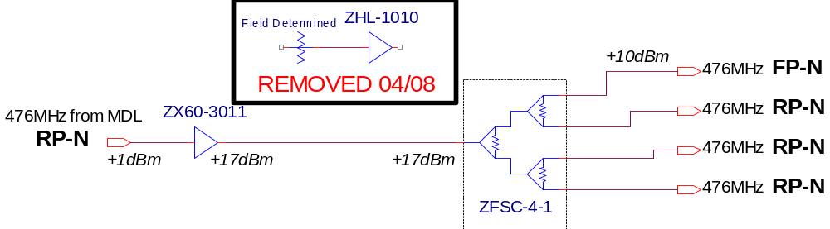
Figure 2. 476MHz Linac Ref. WD-380-208-38-C0

SPAC, Slow Phase and Amplitude Controllers

There are 6 slow PACs used in the reference system.

1. MDL 476MHz - controls the phase of the laser, injector, L1, L2, and timing system.

2. Laser 476MHz - controls the RF reference which the laser oscillator locks to.

3. RF Reference 2856MHz - controls the phase of the RF to the RF reference distribution and to the Local Oscillator, LO, generator.

4. LO Reference 2830.5MHz - controls the phase of the Local Oscillator distributed to the PADs.

5. Clock 102MHz - controls the phase of the 102MHz clock distribution used to clock PADs and PACs.

6. L2 Reference 476MHz - controls the phase of the 476MHz reference which feeds linac sectors 21, 22, 23, and 24.

All the PACs use the PAC control board which has an Arcturus uCDIMM Coldfire based module running EPICS on RTEMS. The uCDIMM is used to setup and load waveforms into the Spartan FPGA. The FPGA is programmed as 2 arbitrary 2048 sample arbitrary waveform generators. In the SPAC mode, the waveforms are constants and written to the 2 DACs when changed through EPICS. The 2 DACs output voltages to the I and Q channels of the modulator. There are two types of RF heads used in the PACs. One is an S-Band module with built in amps, couplers and IQ modulator, figure 3. The other is a VHF unit which covers 102MHz and 476MHz and is made with connectorized amplifiers, couplers, splitters, mixers and filters mounted on a plate, figure 4. The S-Band chassis takes -3dBm input and outputs up to +7dBm. The VHF unit takes +7dBm input and has an output of up to +13dBm.

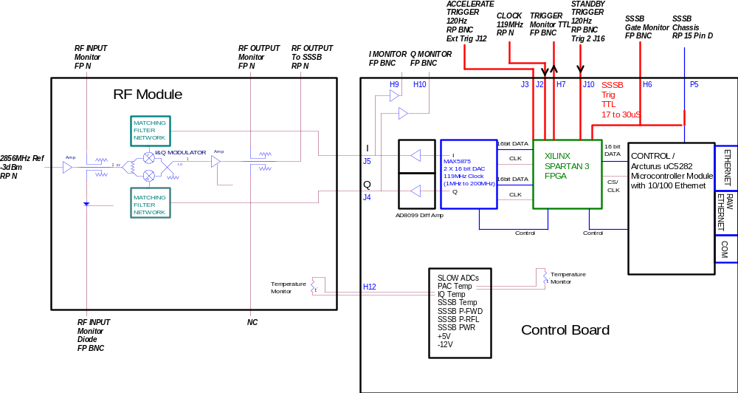
Figure 3. S-Band (2856MHz or 2830.5MHz) PAC Chassis FS 380-208-40-C0

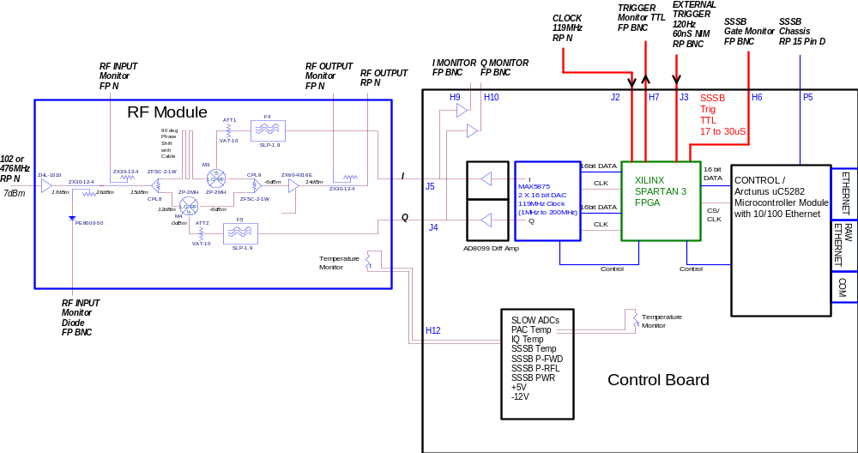

Figure 4. VHF (476MHz or 102MHz) PAC Chassis FS 380-208-40-C0

LCLS 476MHz PLL

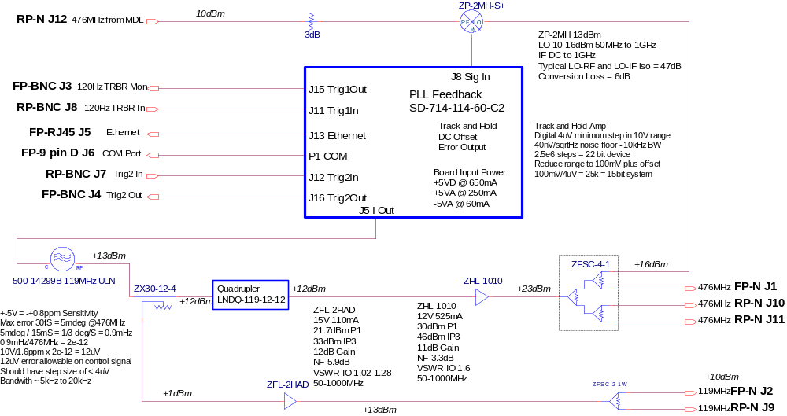
Figure 5 LCLS 476MHz PLL WD380-208-29C0

The amplified 476MHz from the MDL feeds the LCLS 476MHz PLL, shown in figure 5. The track and hold PLL supplies the LCLS LASER with a clean 476MHz signal, taking out the 720degree phase shifts in the linac RF used to fill different PEP buckets and the effects of the 360Hz fiducial. This type of track and hold has been used in SPPS to achieve Beam to RF noise levels of less than 150fS rms jitter as measured by the SPPS EO experiment. The 119MHz Ultra Low Noise (ULN) oscillator has output noise floor of -176dBc/Hz. The oscillator specification is shown in figure 6. A TRBR trigger from LI20 404 is connected to the "Trig 2 In", J7 BNC, on the PLL chassis to trigger the sample start time.

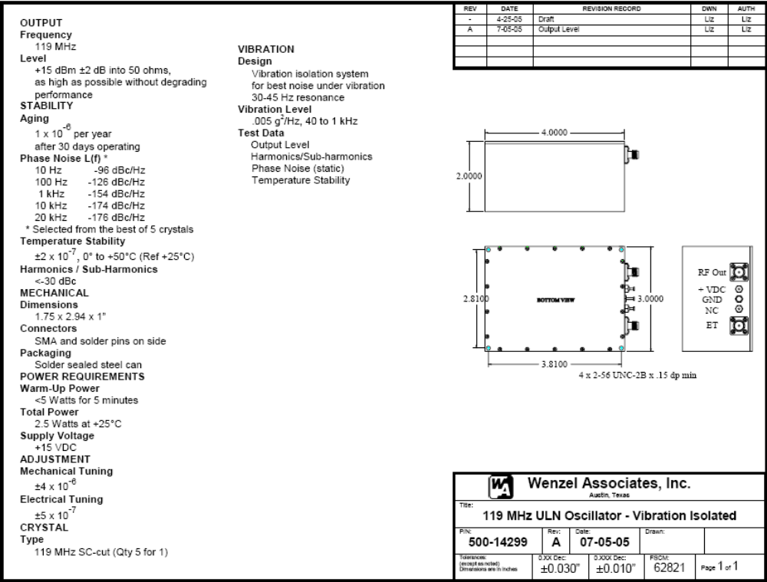
Figure 6. 119MHz Low Noise Oscillator

The noise floor at the output of the quadrupler is expected to be about 3dB higher plus 12dB from multiplication, -161dBc/Hz. The amplifier and output dividers will add less than 1dB of noise to the floor. The output noise floor at 476MHz should be below -160dBc/Hz.

LCLS VHF Dual Distribution

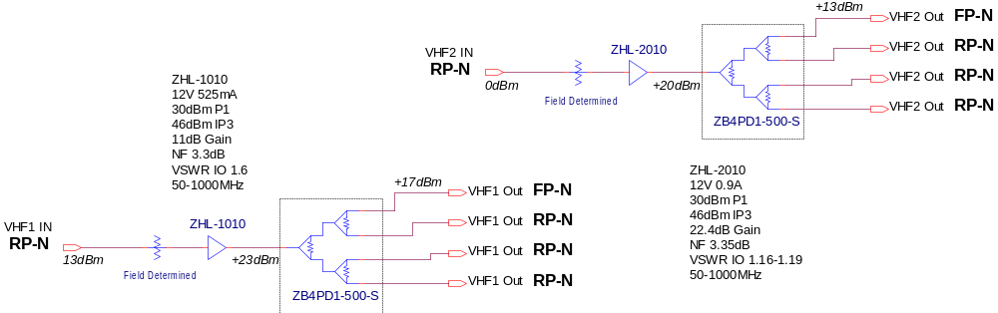
Figure 7. LCLS LLRF VHF Dual Dist. Chassis WD-380-208-34-C0

The LCLS Dual Distribution Chassis is used to fan out the outputs of the 119MHz and the 476MHz from the LCLS 476MHz PLL Chassis. The schematic is shown in figure 7. VHF1 channel is used for the 476MHz signal and the outputs are about +17dBm. VHF2 channel is used for the 119MHz signal and the outputs are about +18dBm.

The input 119MHz noise floor is about -168dBc/Hz. The output noise floor will increase 5dB due to the input 10dB attenuator and by about 1dB due to the amplifier to give an output noise floor of -162dBc/Hz. The 119MHz outputs feed the Laser and the Reference PAD.

The input 476MHz noise floor is about -160dBc/Hz. The 6dB input attenuator and the amplifier will add 2dB to the noise floor, raising it to about -158dBc/Hz. The 476MHz outputs feed the Laser, the 6X multiplier, and the Timing 119MHz Synchronizer.

476MHz to 2856MHz Multiplier

The 476MHz to 2856MHz multiplier is expected to add 16dB to the noise floor, mostly due to multiplication by 6. The output of 2856MHz noise floor is expected to be below -144dBc/Hz. Figure 8 is the drawing for the multiplier and a photo of the RF section in the chassis.

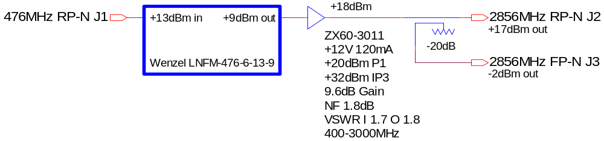

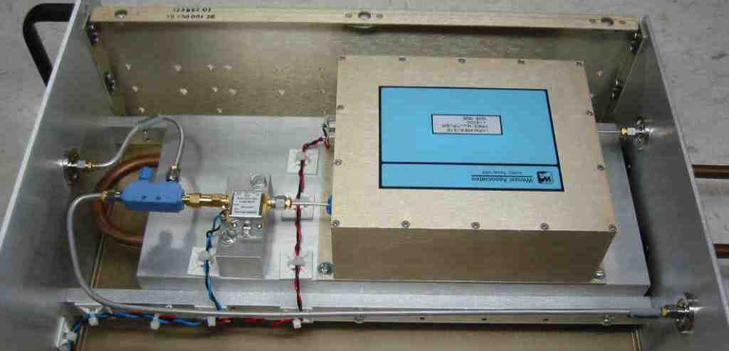

Figure 8. 476MHz to 2856MHz Multiplier FS-380-208-22-C0

S-Band 10W Amp - Distribution Amplifier

An SPAC, Slow Phase and Amplitude Controller, chassis contains an IQ modulator and is used to control the phase and amplitude of the RF feeding the distribution amplifier. The output of the distribution amplifier feeds the 16 way distribution chassis. There are two amplifiers used in the sector 20 RF system, one for the RF, 2856MHz, and another for the LO, 2830.5MHz distribution. Specifications for the amplifier are listed below, and the chassis diagram is shown in figure 9.

Model number AM38A-2.85S-35-40 from Microwave Amplifiers Ltd.

Frequency Range (GHz): 2.800 to 2.900
Gain Small Signal: 35dB min
Gain Flatness: 1dB p-p max
RF Input Drive: +15dBm max
Output Power @ 1dB GCP: +40dBm min
IP3 +50dBm typ
Non-Harmonic Spurious: -60dBc min
Noise Figure @ 25º C: 4dB typ
Output Return Loss: 10dB min, 14dB typ
Input Return Loss: 10dB min, 14dB typ
Power Supply: +12/15V DC, 3.5A max
Connectors: SMA Female
Dimensions (LWH): 150x70x25mm
Operating Temp Range (baseplate): 0 to +60C

Features:

Class A Linear Design
Unconditional stability
Reverse polarity protection
Open & short circuit protection
Over temperature protection

The amplifier will be run at an output power level of 33dBm and maintain the noise floor below -144dBc/Hz.

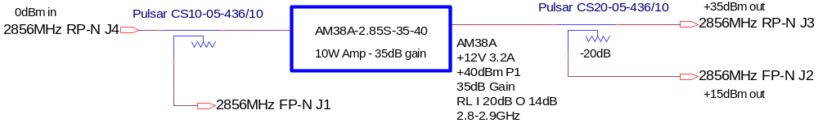

Figure 9. S-Band 10W Amplifier FS-380-208-27-C0

2830.5MHz Local Oscillator Generator

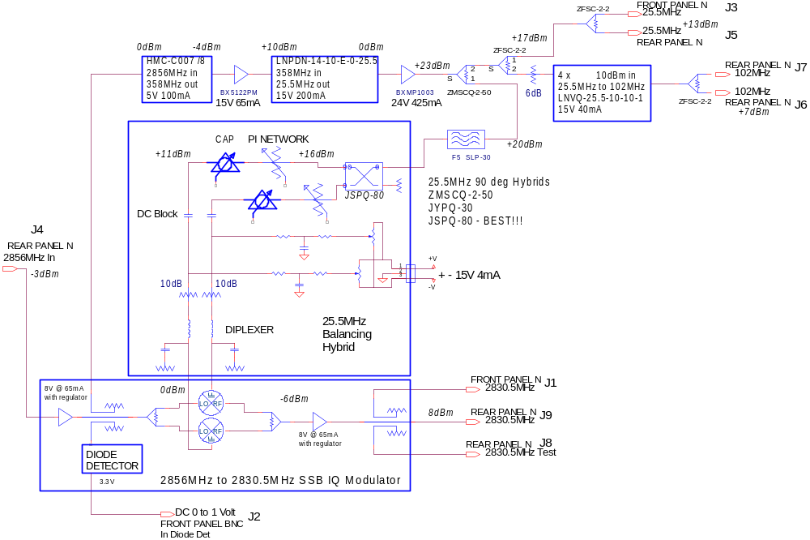

Figure 10. 2830.5MHz LO Generator Block Diagram FS-380-208-28-C0

The 2830.5MHz LO Generator block diagram is shown in figure 10 and a picture of the chassis in figure 11. The noise floor of the 2856MHz feeding the chassis is -144dBc/Hz. The divider output at 25.5MHz is -150dBc/Hz. At 102MHz this is expected to increase by 12dB to -138dBc/Hz.

102MHz noise floor is -138dBc/Hz : -138dBc/Hz x 50MHz x2 SSB = -58dBc
-58dBc is 0.072degs rms or at 102MHz is 2pS rms jitter.

2pS clock jitter on 25.5MHz signal can add -70dBc to the SNR
At 2856MHz -70dBc is 0.32mRadians rms, 0.018Degrees rms, or 18fSrms.

The 102MHz feeds the Clock SPAC, which feeds the VHF 5W Amplifier, which feeds the 16 Way Distribution Chassis. The 16 way distribution chassis fans out the clock to all PADs and PACs in sector 20 and sector 21.

The 25.5MHz signal is routed to the X-Band LO Generator where it is used to SSB generate an LO signal for the X-Band PADs.

2830.5MHz Noise Floor

The noise floor of the 25.5MHz is about -150dBc/Hz. This level should easily be held all the way to the IF port of the mixer where the level is about 0dBm. At this point the 25.5MHz mixes with the 2856MHz in a single side band modulator. The -150dBc/Hz is expected to add 1dB to the 2856MHz input noise level of -144dBc/Hz. This gives the 2830.5MHz a noise floor of -143dBc/Hz.

The RF and LO noise levels of about -143dBc/Hz, an IF mixed product is expected to have a noise level of -140dBc/Hz. In a 10MHz bandwidth the noise level would be -67dBc. This is equivalent to a jitter of 26fS rms.

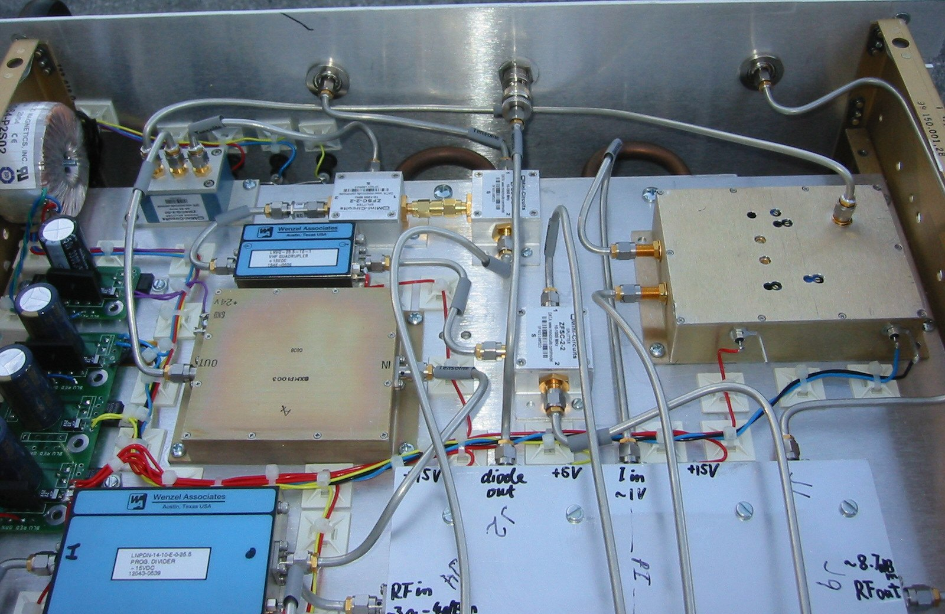
Figure 11. 2830.5MHz LO Generator Chassis FS-380-208-28-C0

L2

L2, LCLS linac 2 between BC1 and BC2, consists of linac klystrons 21-3 to 24-6. The 4 sectors of linac get their 476MHz RF reference from the L2 Amp chassis, shown in figure 12. The 6dBm coupled output is used to supply the reference to sector 21 through a piece of 1/2 inch heliax. The main, 16dBm, output drives a 7/8 inch heliax run through the tunnel to sector 24. Couplers in the 7/8 inch heliax pick off power for sectors 22 and 23. The L2 amplifier is feed from the L2 SPAC.

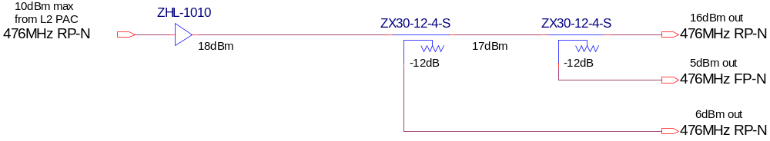

Figure 12, L2 Amp FS-380-208-18-C0

Appendix A

Synchronization of RF Signals wrt Timing Fiducial

Signals of interest: Multiple of 25.5MHz
25.5MHz to generate 2830.5MHz LO for LCLS RF measurements 1
102MHz clock for ADCs and DACs 4
119MHz clean LCLS 119MHz for Laser reference 14/3
119MHz linac locked to fiducial 14/3
119MHz lcls timing system synchronized to linac 14/3
476MHz linac MDL phase distribution 56/3
476MHz LCLS 476MHz PLL used for laser locking 56/3
2830.5MHz LCLS LO to measure phase 111
2856MHz RF 112
11.4GHz RF 448

Every three 25.5MHz cycles, 8.5MHz, all phases line up

There are three items that need to be resynchronized in the RF distribution system:
1. The 119MHz to the laser which can be off by a 476MHz bucket (this has the timing systems 476MHz reference as a harmonic)
2. The 25.5MHz which can be off by a 2856MHz bucket.
3. The laser oscillator which can be out by a 476MHz Bucket.

Following the below items in the presented order to get back to operational conditions.

Turn off any feedback driving the LASER PAC and MDL PAC.

MDL PAC - 119MHz Linac

The MDL PAC shifts the phase of the LCLS injector and L1 RF with respect to the MDL. Since this phase shifter is used to adjust the injection phase into L2, there is a feedback that may move this by as much as ±180 degrees at 2856MHz, or ±30 degrees at 476MHz. The reference 476MHz to the timing system also passes through this phase shifter. This is the first item which needs to be checked since it can shift the phase of the 476MHz going to the timing system. Turn off any feedback driving the MDL PAC. Rotate the phase so that I is about -32000 +-5000 and Q about 0 +-5000. These numbers are good as of April 22, 2008. You should check the archiver and/or MDL PAC window to verify these numbers are close to the operating point.

25.5MHz

The 25.5MHz is generated by division of the 2856MHz by a divide by 112. The 25.5MHz is used to generate the 102MHz clock frequency and the 2830.5MHz local oscillator. For the PADs to read the correct phase, the 102MHz clocks and the 2830.5MHz local oscillator must be at the correct phase with respect to the trigger system. This is accomplished by rotation of the RF Reference phase shifter while monitoring channels 2 and 3 of the Reference PAD.

The two Reference PAD signals used to set up this phase are channel 2, 119MHz FIDO, and channel 3, 25.5MHz. Both signals are viewed from the "Global", "Reference" window, figure A1, first row in the Phase & Amplitude section.

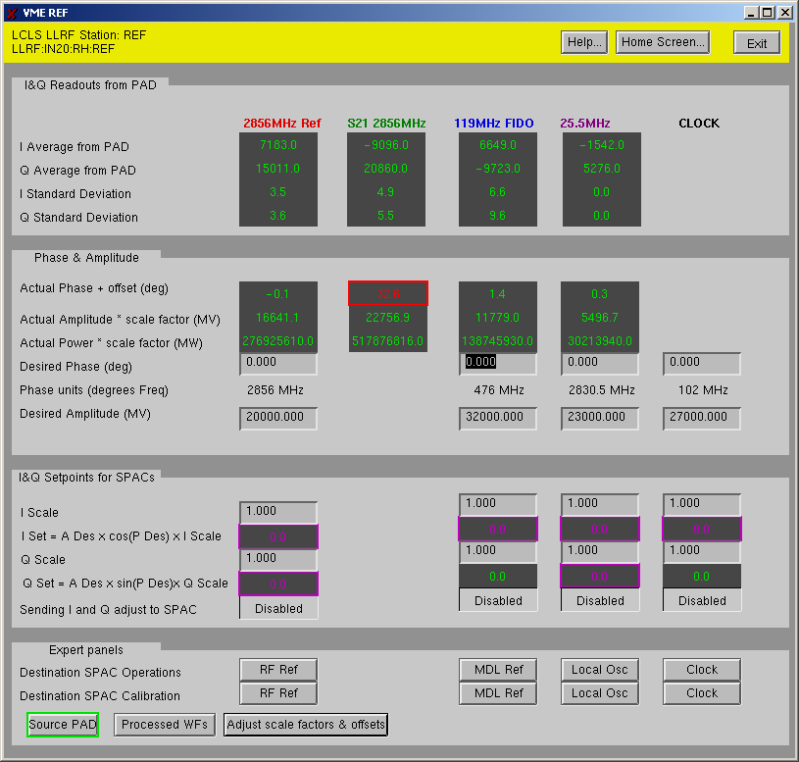
Figure A1, Global Reference Window

The 25.5MHz, since it is divided down from 2856MHz, can be off by a 2856MHz cycle. Resolution of measurement needs to be below 350pS, 3.2 degrees at 25.5MHz or 15 degrees at 119MHz.

Since, the phase of the 102MHz digitizer clock will move with the phase of the 25.5MHz, you will not see the movement of the 25.5MHz phase on Channel 3 of the Reference PAD until it jumps a 119MHz trigger cycle. This will occur about every 28 revolutions.

Alignment of the 25.5MHz is done by full cycle rotations of the RF Ref PAC. First monitor channel 3, 25.5MHz, of the Reference PAD and rotate the RF Ref Phase with the LLRF GUI, Figure A2, to get to 0±3 degrees. Next monitor channel 2, 119MHz FIDO, on the Reference PAD and rotate the RF Ref phase shifter to get to 0±15 degrees. The 25.5MHz is now synchronized to the linac fiducial.

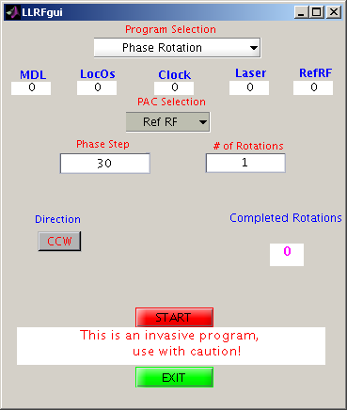
Figure A2, LLRF GUI

102MHz

If the 25.5MHz is synchronized to the linac fiducial, the 102MHz will be synchronized since it is a harmonic.

119MHz Linac

The linac 119MHz is locked to the linac fiducial and the linac timing system. The 25.5MHz adjustment uses this signal as a reference to ensure the LCLS RF is synchronous.

119MHz LCLS
The 119MHz out of the LCLS local oscillator chassis is used for the laser system. The phase can be read from the LASER PAD CH3 "LCLS 119MHz". To synchronize this to the linac fiducial, rotate the MDL PAC one cycle one direction and the RF Ref PAC six cycles the other direction. Both these PACs need to be rotated in a ration of 1:6 to maintain the 25.5MHz phase to fiducial. During rotation of the MDL PAC, the reading on channel 3 of the LASER PAD will not change. This is due to the PAD clock moving with the signal.

476MHz MDL and LCLS
The 476MHz of the LCLS local oscillator is phased locked to the main drive line of the linac to which the timing fiducial is synchronized.

The LASER 119MHz to Linac 119MHz
The Laser 119MHz needs to be synchronized to the Linac 119MHz so the laser does not jump 476MHz buckets. This will be done by changing the laser feedback to lock to the Laser 119MHz phase.

To Finish

Turn on the laser feedback and MDL PAC feedback.

Matlab - RF Sync GUI
The Matlab "RF Sync GUI" when run will perform the above steps and sync the RF system. The GUI is shown in figure A3.
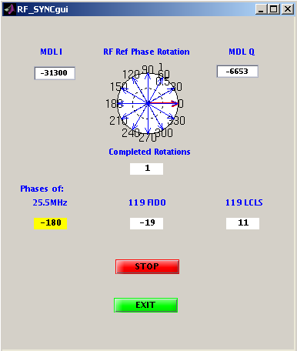
Figure A3, RF Sync GUI
Appendix B RF Cables

The stability of the RF cables is expected to cause larger errors in phase measurement than any other components. The expected errors are tabulated below given in total phase change range based on the length of cable and the surrounding temperature in each environment. The Laser cable routing has been changed to go directly from the RF Hut to the Laser Room through the gallery in a temperature stabilized conduit. The length of the conduit is about 12 ft and the temperature variations are expected to be within ±0.2ºF.
Temperature Coefficient of 2.8ppm/ºF and
Cable length is 1200ºS/ft
All Cables except LASER are less than 100ft
New Laser run is 53ft
Distances feet and errors in degrees S total range
RF Hut Down Linac Wall Injector Total
Unit Ft degS ft degS ft degS ft degS ft degS DegS
Laser 8 0.054 25 0.017 10 0.014 10 0.007 85 0.58 0.68
Gun 8 0.054 25 0.017 10 0.014 10 0.007 40 0.27 0.37
L0-A 8 0.054 25 0.017 10 0.014 10 0.007 30 0.21 0.31
B Phas 8 0.054 25 0.017 10 0.014 10 0.007 20 0.14 0.24
L0-B 8 0.054 25 0.017 10 0.014 10 0.007 20 0.14 0.24
L0-T 8 0.054 25 0.017 10 0.014 10 0.007 10 0.07 0.17
L1-S 8 0.054 25 0.017 50 0.068 0.14
L1-X 8 0.054 25 0.017 60 0.081 0.16
Laser2 8 0.054 15 0.021 30 0.21 0.29

Temperature Variations: RF Hut ±1ºF : Penetration ±0.1ºF : Linac : ±0.2ºF
Shield Wall ±0.1ºF : Injector ±1ºF : Laser Room ±1ºF

Distribution of Cables

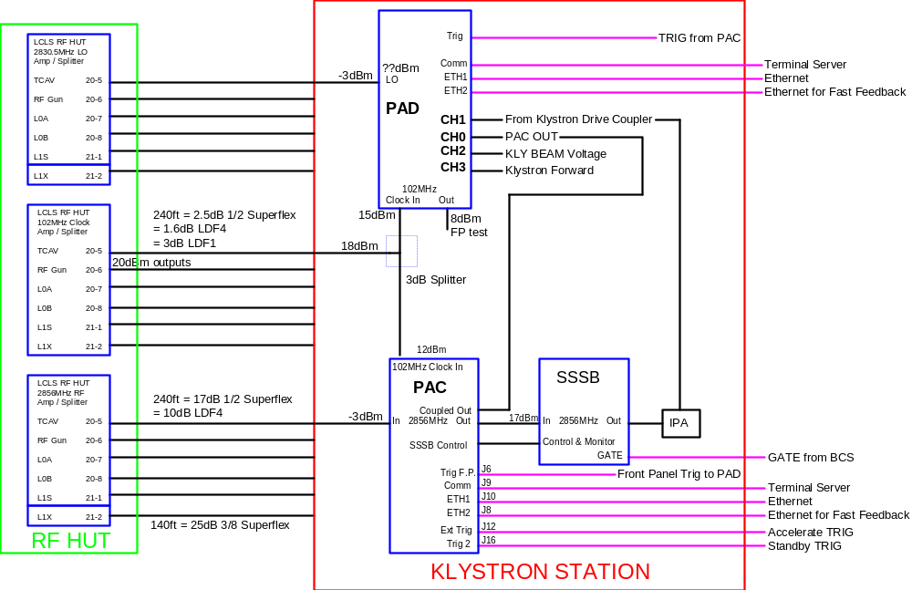

Distribution of RF signals to klystron stations. All of these cables are within local feedback loops.

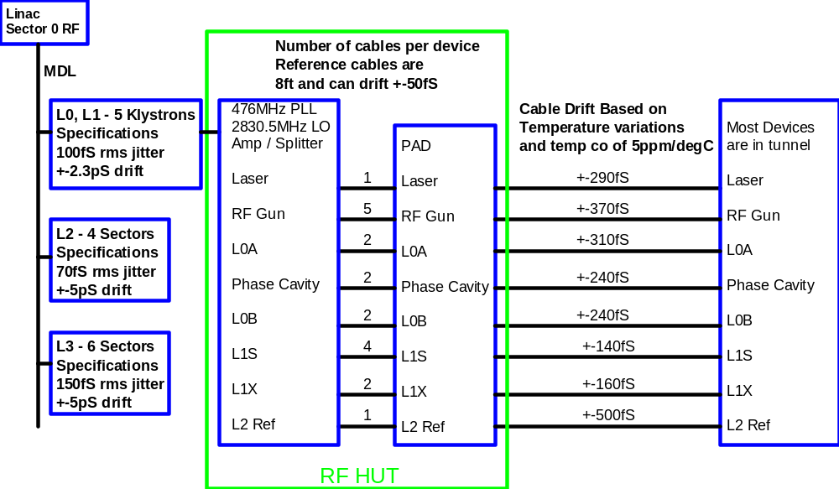
The outline of RF phase reference system to PAD and device to PAD is shown above. Phase errors due to long term drifts are listed. The drifts listed above are calculated from temperature variations and assume that creeping of the cable is minimal.

